Session 2: Database Design and SQL Implementation

1. Objective
To establish the backend data structure for Project-Hub by installing MySQL and designing a relational database with specific tables, constraints, and sample data.

2. Software Requirements
- Database Engine: MySQL Community Server.
- Command Line Interface: Windows Command Prompt (CMD) for executing queries.
- Integrated Development Environment (IDE): Visual Studio Code for script management.

3. Implementation Steps
A. Database Initialization
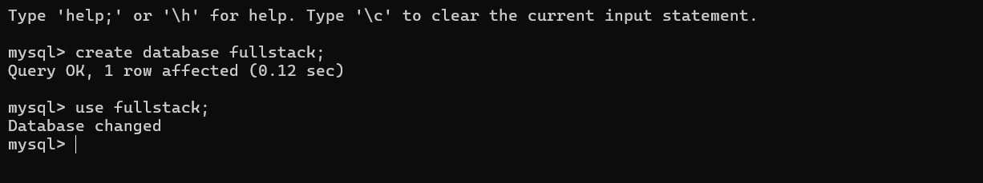

B. Schema Creation (Table Definitions)
Table 1: Student (User Metadata)
- Purpose: Stores the personal and academic details of the students using Project-Hub.
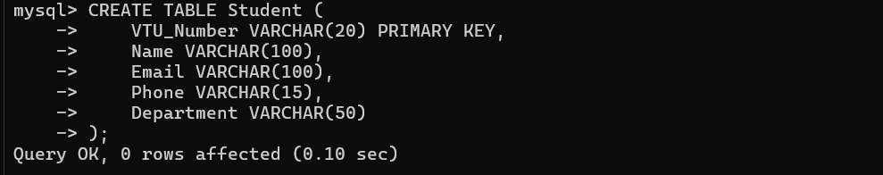

Table 2: Course (Project Details)
- Purpose: Stores the specific project details linked to each student.
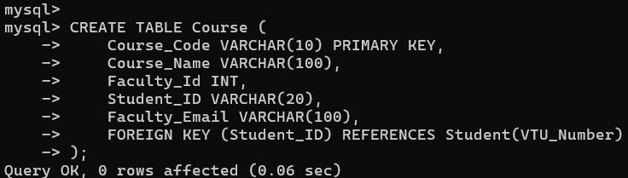

C. Data Ingestion
Populated the tables with 5 initial records to simulate a working environment.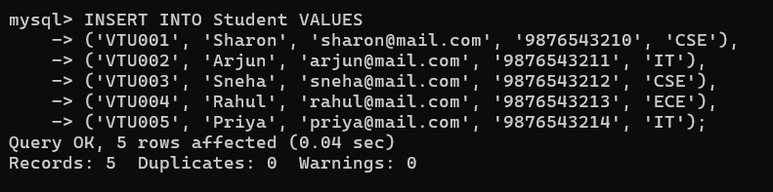
Linking projects to the students in the Course table.
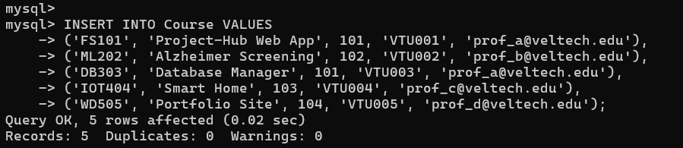

4. Data Querying and Verification
To ensure the data is correctly structured and accessible, the following SQL clauses were applied:
- Filtering (WHERE): SELECT * FROM Student WHERE Department = 'CSE';
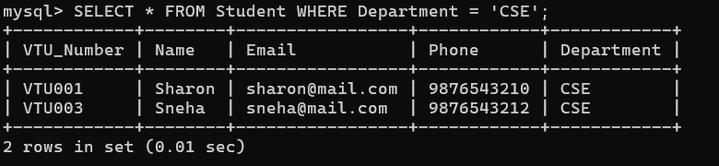
- Sorting (ORDER BY): SELECT * FROM Course ORDER BY Course_Name ASC;
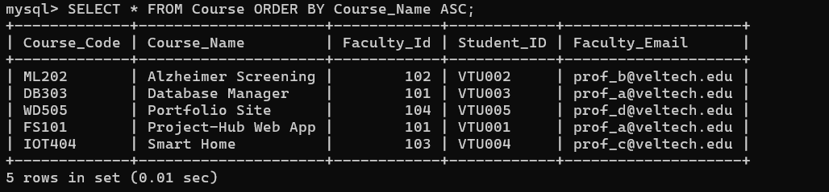
- Pattern Matching (LIKE): SELECT Name FROM Student WHERE Email LIKE '%@mail.com';
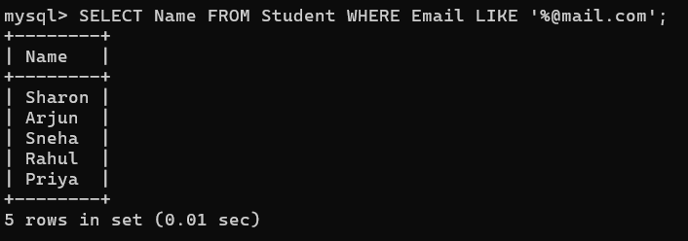
- Constraint (LIMIT): SELECT * FROM Student LIMIT 3;
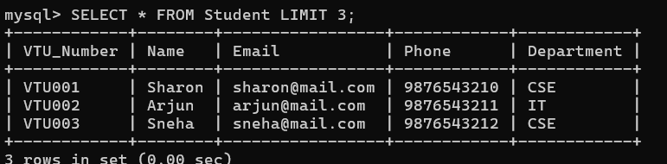
- Aggregation (GROUP BY): SELECT Department, COUNT(*) FROM Student GROUP BY Department;
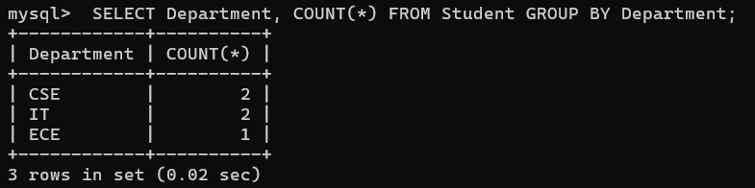

5. Results
The database project_hub was successfully created with a relational link between student users and their projects. All primary and foreign key constraints are functional, and the data is retrievable using standard SQL clauses.

